# Chapter 1

## Introduction

This research was based in Mindanao Avenue, Governor’s Drive Intersection. This chapter will give the background of what the researchers studied. It also tackles about the problems, hypothesis and the objectives of the research itself.

## Background of the Study

Traffic light is a set of automatically operated colored lights, typically red, amber, and green. Traffic signals help in controlling pedestrian and vehicles by means of assigning the priorities to some traffic movements. To stimulate the flow of traffic makes the movement of traffic in a certain intersection in order.

Traffic signals are offering a maximum control to any road intersections. These relay messages of both what you must do and what not to do as a driver. The primary function of the traffic signals as we know is to assign the right of way to the contradicting movements of traffic in an intersection. This is actually done by allowing the conflicting traffic streams to share the same intersection by way of separating the time. Simulations made for analyzing different problems are thought to be powerful tools for analyzing complex problem that change with situation as in traffic light problem.

Transportation is a useful way of bringing people and goods in their destination with a short period of time. Traffic light manages the flow of vehicles in a place. By doing a simulation in the Mindanao Avenue Governor’s Drive intersection, it will overlook the outcome that can be useful not only for the people around on that place but also the people who are using that road for their daily routine in their destination.

Traffic light simulation is a system for transportation that has been controlling by the computer software. Traffic management in the modern era is a helpful tool for everyone. Safeness on the road is important most specially in busy roads. There are incidents, holidays, and calamities that produces heavy load of vehicle that causes traffic along the road. As a solution in these events in a particular road like in Mindanao’s Ave, Governor’s Drive intersection, conducting a simulation will be useful and helpful to describe the purpose of the whole study.

## Conceptual Frameworks

In this project, the researchers used a compact integrated circuit that designed to govern a specific operation in an embedded system which is a microcontroller. To access the said device it is needed to be programmed and it can be done by using the Arduino. The researchers gathered data by means of observing the actual traffic light, its count down, and how the drivers interpret the signals in it. The diagram below is the conceptual framework of the study:

Figure 1.1 Conceptual Framework’s Diagram

## Research Hypothesis

The traffic light simulation in Mindanao’s Ave, Governor’s Drive intersection will have a great impact in resolving the issue about traffic in the said area. It can also give the feedback when designing the real one. It also gives the efficiency and correctness of a design before it actually constructed.

## Definition of Terms

**Traffic lights (or traffic signals)** - are lights used to control the movement of traffic. They are placed on roads at intersections and crossings. The different colors of lights tell drivers what to do. Traffic lights change their colors in the same order every time. In most English-speaking countries, traffic lights usually change in this order:

Red light on: This tells drivers to stop.

Green light on: This means the driver can start driving or keep driving.

Yellow light on: This tells drivers to stop when it is safe to, because the light is about to turn red.

**Simulation** –A simulation is a representation of something you wanted to present in other for a study or research. used especially in order to help people deal with such situations or events.

**Traffic** - the number of vehicles moving along roads, or the amount of aircraft, trains, or ships moving along a route.

**Transportation** - is the movement of humans, animals and [goods](https://en.wikipedia.org/wiki/Cargo) from one location to another. In other words the action of transport is defined as a particular movement of an organism or thing from a point A to the Point B. [Modes of transport](https://en.wikipedia.org/wiki/Modes_of_transport) include [air](https://en.wikipedia.org/wiki/Aviation), [land](https://en.wikipedia.org/wiki/Land_transport) ([rail](https://en.wikipedia.org/wiki/Rail_transport)and [road](https://en.wikipedia.org/wiki/Road_transport)), [water](https://en.wikipedia.org/wiki/Ship_transport), [cable](https://en.wikipedia.org/wiki/Cable_transport), [pipeline](https://en.wikipedia.org/wiki/Pipeline_transport) and [space](https://en.wikipedia.org/wiki/Space_transport). The field can be divided into [infrastructure](https://en.wikipedia.org/wiki/Infrastructure), [vehicles](https://en.wikipedia.org/wiki/Vehicle) and [operations](https://en.wikipedia.org/wiki/Business_operations). Transport is important because it enables trade between people, which is essential for the development of [civilizations](https://en.wikipedia.org/wiki/Civilization).

## Statement of the Problem

1. What is the level of acceptance of the proposed Arduino Simulation for Mindanao Avenue-Governor’s Drive Intersection in terms of the following aspects:

* Functionality
* Reliability
* Usability
* Efficiency
* Maintainability
* Portability

1. What is the level of effectiveness of the proposed Arduino Simulation for Mindanao Avenue-Governor’s Drive Intersection in terms of the following aspects:

* Functionality
* Reliability
* Usability
* Efficiency
* Maintainability
* Portability

## Objectives of the Study

1. To identify the level of acceptance of the proposed Arduino Simulation for Mindanao Avenue-Governor’s Drive Intersection of the following aspects:

* Functionality
* Reliability
* Usability
* Efficiency
* Maintainability
* Portability

1. To identify the level of effectiveness of the proposed Arduino Simulation for Mindanao Avenue-Governor’s Drive Intersection of the following aspects:

* Functionality
* Reliability
* Usability
* Efficiency
* Maintainability
* Portability

## Significance of the Study

The result of this study will may benefit these people as follows:

**Students -** This research can be used by other students to be their guide and it can also be their reference in conducting a research. They will have a lot of information about the importance of having a traffic light and what will be the outcome of having this on their area.

**Barangay Officials -** This research can be passed in the barangay officials. It can be used for having a project building a traffic light in Mindanao’s Ave, Governor’s Drive intersection.

**Teachers -** This research can be used as reference for their discussions. It can give a lot of information in traffic light and also in traffic light simulation. Simulators can be used as an effective means for teaching or demonstrating concepts to students.

This is particularly true of simulators that make intelligent use of computer graphics and animation. Such simulators dynamically show the behavior and relationship of the traffic light simulation, thereby providing the user with a meaningful understanding of the system's nature

**Drivers -** This research can be used as a manual for the drivers on how to act right when they’re on the traffic light area.

**Commuters -** This research will give them a better idea on how to act towards to a traffic light area and how the traffic light affect the roads and where it is located most.

**5**

**Future Researchers -** This research can be used as a reference in the future, and can be improvised with the permission of the researchers.

**Pedestrians -** This research can be used as a guide on for pedestrians to identify what are those signals for them to find out when to cross.

**Proponent -** Even the researchers gain benefit in the actual project in terms of acquiring new knowledge and experience. It can also be a subject in the research used as a reference.

## Scope and Delimitation of the Study

The focus of the study is about the traffic light simulation in Mindanao Avenue, Governor’s Drive intersection. It only allows us to see the outcome of the study.

The function of the simulation in this project is to present what is the actual setting of the given intersection which can help the actual situation in terms of traffic.

This traffic light simulator using Arduino microcontroller has no counter just like the normal traffic light. It only shows the creativeness of the simulation using Arduino microcontroller. One of the delimitation of the microcontroller is there is no counter to indicate in the outside part of the simulation.

# Chapter 2

This chapter focuses the review related literatures about the topic. It will give information from the other author that will help the study to be concrete.

## Review of Related Literature

These literatures and studies act as framework to provide great help to the researchers’ ideas and information about the research topic.

Traffic in the Philippines has been one of today's problems. It's been emerging since the volume of cars has emerged to a number.  Based in the report of CNN Philippines, Manila topped the survey for the longest minutes spent commuting from home to office with an average time of 45.5 minutes. It even was named as having "the worst traffic on Earth," based on a global evaluation conducted by Waze, a GPS based navigation app.

Senator Ralph Recto estimates that the Philippines suffers around a P2.6 billion (or $55.8 million) economic loss each day created by traffic congestion.

John Forbes, senior advisor of the American Chamber of Commerce of the Philippines, warns of Metro Manila’s risk of becoming “uninhabitable” by 2020 if vehicles continue to increase while roads and infrastructure remain the same.

Simulation has an advantage over these methods in that it allows us to forecast things that have never happened before and to run scenarios outside of historical bounds. According to Mr. Dejan Duzevik, Simulation is an excellent approach to analyze problems when the available data is limited, since no data is necessary to construct a simulation. Validating a simulation, however, often requires multiple data sources to achieve a great degree of confidence in its representation of real-world dynamics. The process of validation is a disadvantage for simulation when comparing to data analytics approaches, since validating simulations is often more difficult.

For example, if the researchers wanted to simulate traffic on a road, they would not need any data to start. They would construct a simulation that incorporates modeled cars, driver behaviors, and road conditions: They will have a traffic simulator.

According to Donald Craig, simulators can be used as an effective means for teaching or demonstrating concepts to students. This is particularly true of simulators that make intelligent use of computer graphics and animation. Such simulators dynamically show the behavior and relationship of all the simulated system's components, thereby providing the user with a meaningful understanding of the system's nature.

According to Ashwin Vinod, Traffic lights serves as a coordinators on the road, it control the flow of the ever-increasing number of vehicles on roads and it also help in preventing unexpected accidents.

Traffic congestion is really a problem and if the government implements ways into action and if everyone does his or her part, traffic issues can be possibly resolved and all of the people will benefit to this actions.

# Chapter 3

## Research Methodology

In this chapter, The researches discussed the research design, population and sampling techniques, respondents of the study, research instruments and data gathering procedure and Statistical Treatment of the data.

## Research design

The researcher chose a survey research design to answer the questions easily and also to find out the needs of people regarding to the research.

### Block Diagram

The block diagram is a simple presentation on how many LEDS connected and what color is it.

Green

Yellow

Red

Green

Yellow

Red

Green

Microcontroller

Green

Yellow

Red

Figure 2.1 Block Diagram

### Flow Chart

Figure 3.1 shows how the program runs. It is the guide of the programmer on how to execute the program.

**2**

2

Count--

**Figure 3.1 Flowchart**



3

Count--

4

Turn Red_OFF

Turn Red_ON

**2**

3

Count>0

Count=6

Turn Yellow_OFF

Turn Yellow_ON

Count>0

**2**

2

Count=3

Turn Green_OFF

Turn Green_ON

Count--

Count>0

Count=6



1

1



2

2

Count>0

1

### Program Code

The Following code was used by the researchers in the Arduino micro controller enable to perform the whole simulation of the traffic light:

const int R1=7,Y1=6,G1=5, R2=10,Y2=9,G2=8, R3=13, Y3=12, G3=11, P=4, P1=3;

void setup(){

Serial.begin(9600);

pinMode(R1,OUTPUT);

pinMode(Y1,OUTPUT);

pinMode(G1,OUTPUT);

pinMode(R2,OUTPUT);

pinMode(Y2,OUTPUT);

pinMode(G2,OUTPUT);

pinMode(R3,OUTPUT);

pinMode(Y3,OUTPUT);

pinMode(G3,OUTPUT);

pinMode(P, OUTPUT);

pinMode(P1, OUTPUT);

} void loop(){

for(int a = 18; a>0; a--){

digitalWrite(R1, LOW);

digitalWrite(R2, HIGH);

digitalWrite(R3, HIGH);

digitalWrite(P, LOW);

digitalWrite(P1, HIGH);

Serial.println("Red2, Red3, Pedestrian Red");

Serial.println(a);

if(a>3){

digitalWrite(G1, HIGH);

Serial.println("Green1");

Serial.println(a);

delay(1000);

}

else{

digitalWrite(G1, LOW);

digitalWrite(Y1, HIGH);

Serial.println("Yellow1");

Serial.println(a);

delay(1000);

}

}

LED_OFF();

for(int a = 18; a>0; a--){

digitalWrite(R1, HIGH);

digitalWrite(R2, LOW);

digitalWrite(R3, HIGH);

digitalWrite(P, HIGH);

digitalWrite(P1, LOW);

Serial.println("Red1, Red3");

Serial.println(a);

if(a>3){

digitalWrite(G2, HIGH);

Serial.println("Green2, Pedestrian Green");

Serial.println(a);

delay(1000);

}

else{

digitalWrite(G2, LOW);

digitalWrite(Y2, HIGH);

Serial.println("Yellow2");

Serial.println(a);

delay(1000);

}

}

LED_OFF();

for(int a = 18; a>0; a--){

digitalWrite(R1, HIGH);

digitalWrite(R2, HIGH);

digitalWrite(R3, LOW);

digitalWrite(P, LOW);

digitalWrite(P1, HIGH);

Serial.println("Red1, Red2, Pedestrian Red");

Serial.println(a);

if(a>3){

digitalWrite(G3, HIGH);

Serial.println("Green3");

Serial.println(a);

delay(1000);

}

else{

digitalWrite(G3, LOW);

digitalWrite(Y3, HIGH);

Serial.println("Yellow3");

Serial.println(a);

delay(1000);

}

}

LED_OFF();

}

void LED_OFF(){

digitalWrite(R1, LOW);

digitalWrite(Y1, LOW);

digitalWrite(G1, LOW);

digitalWrite(R2, LOW);

digitalWrite(Y2, LOW);

digitalWrite(G2, LOW);

digitalWrite(R3, LOW);

digitalWrite(Y3, LOW);

digitalWrite(G3, LOW);

digitalWrite(P, LOW);

digitalWrite(P1, LOW);

}

### Phasing

The phasing shows how the traffic light conducts the vehicles in the intersection.



Mindanao Ave.

To Carmona

To

Dasmariñas

G o v e r n o r ’ s D r i v e

G o v e r n o r ’ s D r i v e

Mindanao Ave.

To

Dasmariñas

To Carmona

**Figure 4.2 2nd Phasing**

**Figure 4.1 1st Phasing**

G o v e r n o r ’ s D r i v e

To Carmona

### 

To

Dasmariñas



Mindanao Ave.

### 

**Figure 4.3 3rd Phasing**

### Materials

|  |  |  |
| --- | --- | --- |
| No. | Specification | Quantity |
| 1 | Arduino Micro Controller | 1 |
| 2 | Resistor | 9 |
| 3 | Switching Adaptor | 1 |
| 4 | Wire | 18 |
| 5 | Light Emitting Diodes | 11 |
| **Table 1.1 Table of Materials** | | | |

The table below shows the materials needed to create the simulation:

* **Gizduino LIN controller**
* 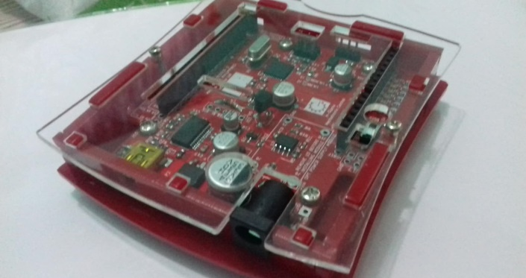The figure 5.1 shows the device that runs the program to the simulation.

**Figure 5.1 Guizduino Micro Controller**

* **Resistor**
* The figure 5.2 shows the device that limits the flow of voltage in the Light Emitting Diodes in the simulation.

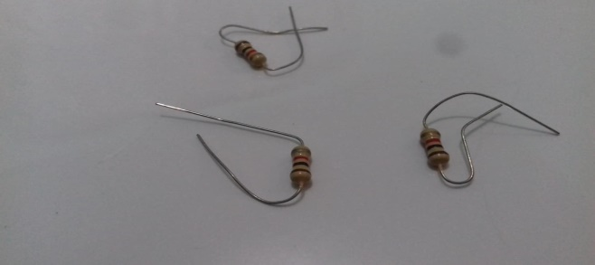

**Figure 5.2 Resistor**

* **Switching Adaptor**
* The figure 5.3 is used as a new source of electricity that supplies the microcontroller when the program is uploaded on the device.

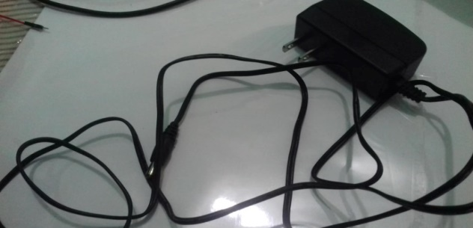

**Figure 5.3 Switching Adaptor**

* **Wires**
* The figure 5.4 classifies as male to male and female to male type of wire that serves as a conductor of electricity from the source (micro-controller).

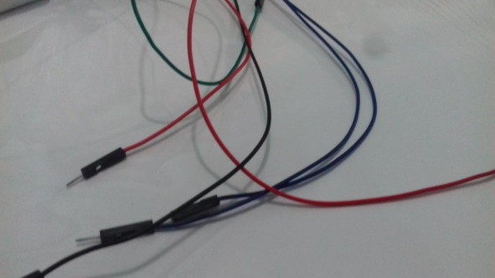

**Figure 5.4 Wires**

* **Light Emitting Diodes**
* The figure 5.5 is used as a light representation on a traffic light and composed of Yellow, Green and Red colors.

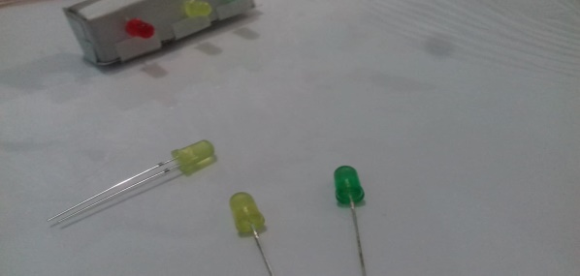

**Figure 5.5 Light Emitting Diodes**

## Population and Sample Techniques

The following table shows the number of respondents in the survey:

|  |  |  |
| --- | --- | --- |
| **Respondents** | **No. of Respondents** | **Percentage** |
| **Pedestrians** | **25** | **25%** |
| **Drivers** | **25** | **25%** |
| **Commuters** | **25** | **25%** |
| **Total** | **75** | **75%** |

**Table 2.1 Summary Table of the Survey**

## Respondents of the Study

The researchers conducted a survey in the area of Mindanao Avenue, Governor’s Drive Intersection. The researchers came up in giving a survey forms on the following respondents, 25 pedestrians, 25 drivers and 25 commuters for the total of 75 respondents.

## Research Instrument

The researchers conducted a survey for collecting data for this study. It measures how the traffic light and traffic light simulation important for other people. This survey contains 10 questions to be answered either Yes or No:

1. Do you know the importance of the traffic light?
2. Is it helpful to place a traffic light in Mindanao Avenue Governor’s Drive Intersection?
3. Do you agree to have a traffic light?
4. Is it good to have a traffic light first before building other modern technology that will help to innovate on your place?
5. Does everyone regulate the rules and regulation in traffic light?
6. Is there any punishment for those who didn’t obey the rules of traffic light?
7. Is it true that traffic light is just a decoration?
8. Do traffic light still useful nowadays?
9. Do you know the importance of having a traffic light simulation?
10. Is it important to have a traffic light simulation first before doing the actual traffic light?

## Validation of Research

This research would be verified by the following person:

* Mr. Norberto Gesite
* Ms. Mary Jane Bayonas
* Ms.Myoren Angara

## Data Gathering Procedure

This research used survey as a questionnaire to gather data. The researchers provide 10 questions that had been answered by 75 respondents in the target area. It includes 25 pedestrians, 25 drivers and 25 commuters that had been participates the survey.

# Chapter 4

## Project Description

The figure below is the top view of the miniature that the researchers created to present the actual look of the area.

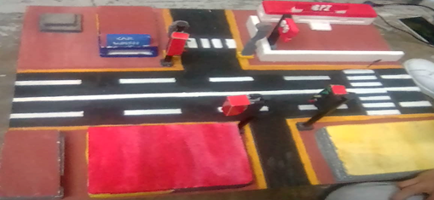

## Project Structure

The following image of the traffic light simulation was constructed with 1 micro controller to program the whole simulation, 10 resistors to limit the flow of electricity in L.E.D, 4 green L.E.D, 3 red L.E.D, 3 yellow L.E.D.

## Project test result capabilities and limitations

The following table represents the result of testing the simulation’s quality:

Function Test 1 Test 2 Test 3

GREEN

YELLOW

RED

TIME

**√**

**√**

**√**

**√**

**√**

**√**

**√**

**√**

**√**

**√**

**√**

**√**

## Project evaluation

These following tables are the results of evaluation in 25 respondents:

|  |  |  |
| --- | --- | --- |
| A. Functionality | Mean | Remarks |
| I. Ease of operation | 4.44 | Very Good |
| II. Provision for Comfort and Convenience | 4.46 | Very Good |
| III. User Friendliness | 4.4 | Very Good |

|  |  |  |
| --- | --- | --- |
| B. Reliability | Mean | Remarks |
| I. Uniform Traffic Light Simulation for Vehicles | 4.5 | Very Good |
| II. Uniform Traffic Light Simulation for Pedestrian | 4.42 | Very Good |
| III. Transition and Timing | 4.54 | Very Good |

|  |  |  |
| --- | --- | --- |
| C. Efficiency | Mean | Remarks |
| I. Able to perform uniform Traffic Light simulation | 4.6 | Very Good |
| II. Efficiency in terms of Time/labor spent | 4.56 | Very Good |
| III. Cost=effective | 4.6 | Very Good |

|  |  |  |
| --- | --- | --- |
| D. Maintainability | Mean | Remarks |
| I. Maintainability of Program used | 4.42 | Very Good |
| II. Maintainability of Hardware design | 4.42 | Very Good |
| III. Maintainability of circuit | 4.43 | Very Good |

|  |  |  |
| --- | --- | --- |
| E. Portability | Mean | Remarks |
| I. Suitability of design | 4.43 | Very Good |
| II. Appropriate program used | 4.47 | Very Good |
| III. Appropriate hardware used | 4.52 | Very Good |

|  |  |  |
| --- | --- | --- |
| F. Usability | Mean | Remarks |
| I. Availability of Materials | 4.54 | Very Good |
| II. Availability of Tools and Machine | 4.56 | Very Good |
| III. Availability of Software Requirements | 4.6 | Very Good |

# Chapter 5

## Summary of findings

The researchers had a chance to conduct a survey in the said intersection. Most of the respondents got a similar answers to the survey and a very few does change. The researcher found out based in the survey result, that people in the area of Mindanao Avenue-Governor’s Drive Intersection are hoping also for a traffic light to be built in that area.

## Conclusion

The researchers concludes that by making a simulation of the given intersection, it provides an actual representation of what a traffic light system would look like if it was implemented in the area. It also proves according to the respondents that in Mindanao Avenue-Governor’s Drive Intersection really needed a traffic light to manage the flow of vehicles and safety of pedestrians in that area.

## Recommendation

This research recommends the implementation of the said project with a certain adjustments to the design that the researchers provided.

Using google map as a guide in creating the miniature can be easily determined the top view of any places and land marks in the place. It provides also the proper placements and designs of infrastructures.